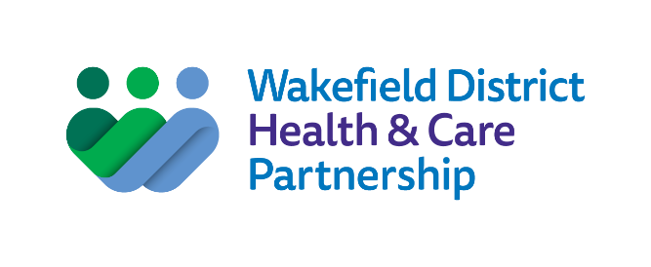

Wakefield District

Health and Wellbeing

Strategy

  - 2022 – 2025

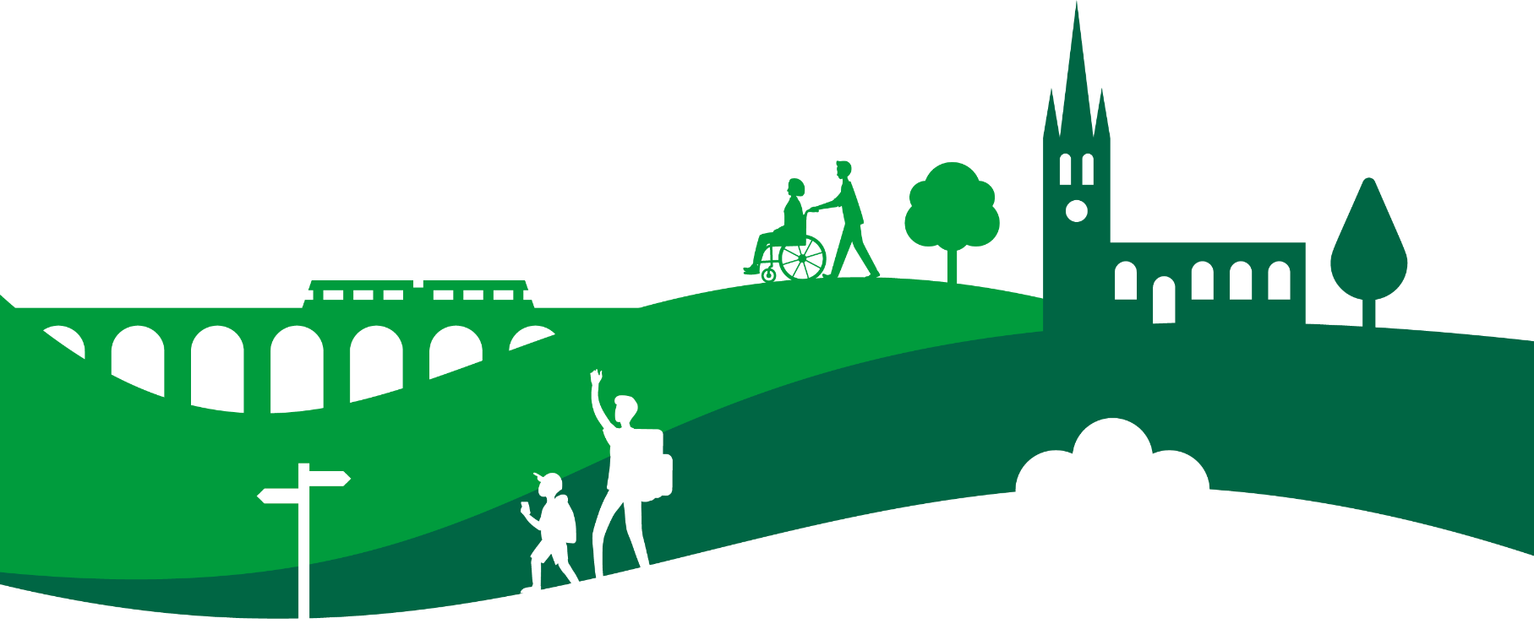

Foreword

Our aim is for the people of Wakefield district to live longer, healthier lives.
The Health and Wellbeing Strategy is owned and driven by the Health and Wellbeing Board for Wakefield district, which is made up of representatives of organisations who are working to deliver this ambition.
This includes local councillors, leaders in health and social care, voluntary organisations, housing, police and fire services, as well as Healthwatch, who ensure the district’s residents are involved, as we all have a part to play to improve health.
We have shown that if organisations work together, we can make a real difference to the health of our communities.
The pandemic has had a huge impact on the physical and mental wellbeing of local people, on our health and care system and on the economy. It has shone a light on inequality and its effect on people’s health. NHS, social care and voluntary organisations have worked together better than ever before. Our Health and Wellbeing Strategy builds on what we have learned.
Examples of the improvements we have made since our first Health and Wellbeing Strategy was developed in 2013 include:
- Support for children and families has been strengthened through social care, health and education working together
- Hundreds of people have been helped to stop smoking and it is more difficult for illegal tobacco products to get onto our streets
- We have taken action to reduce the impact of poverty and are helping people get into work, to access benefits and to have healthy food and a warm home
- More children and adults are taking part in activities run by voluntary and
- community organisations to promote mental wellbeing
- We have improved prevention and treatment of mental ill health and are doing more to support people who are at risk of suicide
- Older people can live independently in their own homes for longer through access to comprehensive care and technology
- All major planning developments in the district are designed to enhance the health and wellbeing of local communities

- We have reduced deaths and disability from strokes through prevention work and better treatment
- Joined up work with housing providers means more people live in good quality homes
- People with learning disabilities are better supported, with an increased focus on supporting people to stay well
- Closer working between GPs, voluntary organisations, care homes, hospitals, community and social care means we can respond to ever increasing demand
We want everyone in the district to enjoy the best possible mental and physical health regardless of where they are born, live, grow, work and age. Where people have health needs, we want them to have access to excellent care, tailored to their needs that helps them to live independently.
This Health and Wellbeing Strategy describes how organisations will join up to work with local people to improve the health of the population overall.

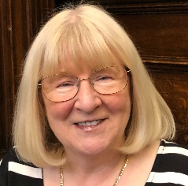
Councillor Maureen Cummings, Chair of Wakefield District Health and Wellbeing Board
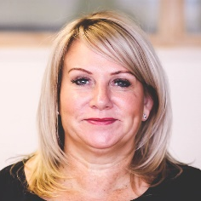
Jo Webster, Accountable Officer for Wakefield District Health & Care Partnership, Accountable Officer of NHS Wakefield Clinical Commissioning Group, Corporate Director for Adults and Health at Wakefield Council
Ann Hartley, Director of Public Health, Wakefield Council

Contents

Our aim is for the people of Wakefield district to live longer, healthier lives. 2
Our priorities 5
Why do we need a Health and Wellbeing Strategy? 6
What do we know about the health of the people who live in Wakefield district? 7
What the facts and figures tell us? 7
What people have told us 9
What our partners have told us 10
Priorities and work programmes 11
A healthy standard of living for all: what changes can you expect to see by 2025? 11
A healthy start in life for every child: what changes can you expect to see by 2025? 12
Preventing ill-health: what changes can you expect to see by 2025? 13
Sustainable communities: what changes can you expect to see by 2025? 14
The tools we will use to help us deliver change 15
How will we know we are making a difference? 16
A healthy standard of living for all 16
Giving every child the best start in life 16
Preventing ill health 17
Sustainable communities 17
How we will organise ourselves to deliver 18

Our priorities
Our priorities for health and wellbeing are based on what we know makes the biggest difference to improving people’s health.
They are taken from the Marmot Review, a national, evidence-based framework, which looks at what keeps us healthy, from before we are born and as we grow, live, work and get older.
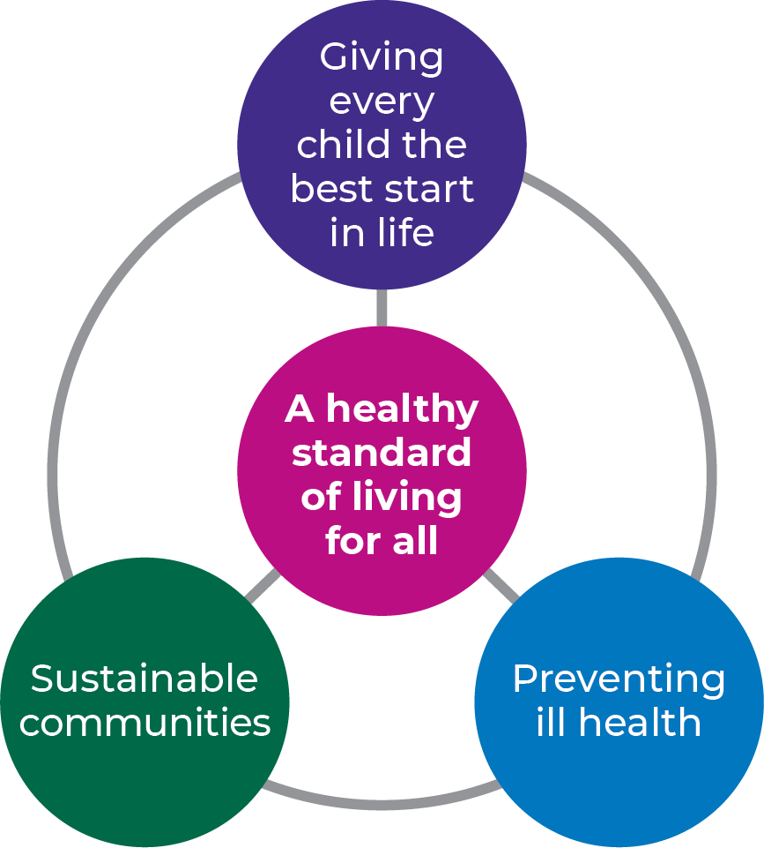

'Fair Society Healthy Lives' was published in February 2010 and concluded that reducing health inequalities would require action on six policy objectives, which are woven into our health and wellbeing priorities:
- Give every child the best start in life
- Enable all children, young people and adults to maximise their capabilities and have control over their lives
- Create fair employment and good work for all
- Ensure a healthy standard of living for all
- Create and develop healthy and sustainable places and communities
- Strengthen the role and impact of ill-health prevention

The Marmot Review: by Michael Marmot, Peter Goldblatt, Jessica Allen, et al. (2010) can be found on the .gov.uk website.

Why do we need a Health and Wellbeing Strategy?
The Health and Wellbeing Strategy is a high-level vision and direction for health improvement for the Wakefield district.
It recognises the huge amount of excellent work that is taking place through many organisations, work programmes and individuals. Not all of this can be captured in a single document and there will be detailed plans for each element of the strategy.
We have taken a rigorous approach to refresh the strategy and to decide how all parts of the district should focus our collective energy to build on the good work we have already done to improve population health:
- We have reviewed the work that we have done so far to improve health and wellbeing
- We have studied information about the health of local people and what it is about the district, the environment and the way we live that affects how healthy we are
- We have asked local people what is important to them about good health and what helps them stay well
- We have asked leaders in different organisations, employers and businesses what they are doing to improve the health of local people and what more they could do

What do we know about the health of the people who live in Wakefield district?
More than 350,000 people live in Wakefield district.
The rich diversity of our backgrounds, experience and lifestyles is what makes the district a great place to live. However, these differences also have a big impact on our health.

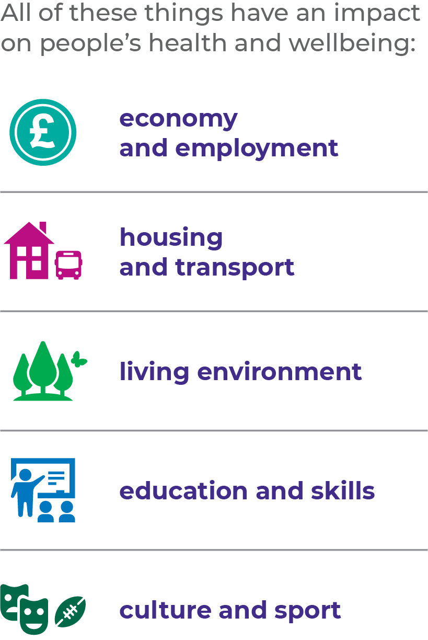

What the facts and figures tell us
From studying the data about the health of the population, we know that there is still too much of a gap between the health of people in the most well-off areas of the district and people who live in poorer areas.
Statistics tell us that generally people in the Wakefield district will die younger than in other parts of the country and will spend more years of their lives in poor health.
People’s health and life chances are heavily influenced by the early years of their lives: too many babies are born to mothers’ who smoke, less than half of new mums breast feed their babies, many children grow up in low-income households and in families that need support from services and a lot of children lack basic skills when they start school. Mental ill health affects more people than in other parts of the country and self-harm and deaths by suicide are high. We also know that a lot of health problems that affect people in the Wakefield district could be changed with the right support and resources to address the causes, such as smoking, drinking, poor diet and lack of exercise.

Ten facts about the health of people in Wakefield district:
- We are living longer with more illness than ever before
- People living in the most well-off areas of the district on average live eight years longer than those living in the poorest areas
- Cancer and cardiovascular disease are increasing in people aged over 75
- Less than half of new-born babies are breast fed
- Childhood obesity is rising faster than elsewhere in the country in all age groups
- More than half of children are growing up in low-income households
- One in five adults are smokers
- One in every hundred hospital admissions is related to substance misuse
- One in three people suffer from a mental illness
- Air pollution kills over 150 people every year

What people have told us
We asked local people to tell us about their health and how it affects their lives.
Most people said their physical health was average or good but a lot of people said their mental or emotional health was poor. People aged 18-24 were most likely to feel positive about their physical health. Young people aged 13-24 were most likely to rate their mental health as very poor. Under 13s and those aged 65-79 were most likely to feel good about their mental health.

What makes you feel healthy:
“Spending time with family and friends. Having a focus on self-care.”
When asked what living a healthy life meant to them, most people said physical exercise and healthy food were important. Feeling happy, having healthy relationships and feeling mentally well were also valued. Physical activity, eating well and access to social activities were the main things that people felt would help them live more healthy lives.
Very few people said medication or medical appointments would make a difference. However, one in eight people said better access to health services would help.

What difference would being healthy make to you:
“Everything. It would be a dream come true.”
“It would enable me as I get older to live a full life.”
Whilst most people felt they were living a healthy life, almost one in five said they were not. People with mental health problems or a learning disability were much more likely to report not living a healthy life.
When asked what stops people living a healthy life, the biggest barrier was time and work, with slightly less people saying poor physical or mental health or lack of motivation got in the way. Poverty and the cost of healthy food was also an issue.
When asked what difference a healthier life would make to them, most people believed it would make them happier.

If money was no object, what could be put in place to help everyone live a healthier life?
“Food co-operatives selling locally grown food at affordable prices - why not get allotments to sell excess produce?”
“Proactively limit the number of fast-food outlets in an area.”
“Befriending and social opportunities for isolated individuals including care homes.”
“Classes and clubs available in all local community centres, for all ages and abilities.”

What our partners have told us
We asked leaders in local organisations such as police, planning, transport, leisure and business to tell us about what they were doing to improve the health of local people. All organisations felt they had a role to play and most were already doing work that directly improves health, such as offering services that improve physical activity, providing health or social care in community settings, promoting community safety or supporting victims of crime.
Most felt they could do more to promote messages about health to their service users, customers, children and families or to their workforce. Organisations also felt they could include more measures to improve health into their service offer.
Employers said they wanted to be able to support their staff with physical and mental health and more information about the help that is available. They also wanted longer-term thinking and planning so that resources can be targeted more effectively, especially across the voluntary and community sector. Organisations said they had skills and knowledge that they could use to help health and care services make improvements.

“When I think about it, it’s clear that while it’s not our core mission to improve people’s health, it’s in our interests to make sure that the people we serve and that the people who work for us are healthy – both physically and mentally.” Local business leader

Priorities and work programmes
The Health and Wellbeing Board will act as a driver for change, bringing together different organisations and communities.
We will be ambitious and set ourselves challenging goals. We will focus on doing things that help deliver improvements that we can measure in all the areas that we have identified as priorities. We will work to engage all parts of our district to ensure decisions we make in the next three years help to make the whole of Wakefield district a healthier place to live now and in the future.

A healthy standard of living for all: what changes can you expect to see by 2025?
The Council is leading a five-year strategy for economic growth, which will focus on developing the local economy so that it enables people to live in better health. Our Health and Wellbeing Strategy will link in with this and with the Wakefield Council Corporate plan to address challenges that affect people’s health.
- To help reduce poverty, we will encourage more apprenticeships and employment opportunities for people who may find it harder to get work such as care leavers, people with disabilities and minority ethnic groups.
- We will focus action on reducing health inequalities in our most deprived neighbourhoods by connecting people with services and with each other.
- We will encourage employers to develop carer friendly workplaces and will improve direct support to unpaid carers, including children with caring responsibilities.
- We will help people to get access to benefits if they cannot work or have a low income. We will also help them make the most of their income by providing financial advice and support.
- We will support schemes that provide good quality, warm and affordable housing and address fuel poverty.
- We will tackle issues that push families further into poverty such as smoking and harmful alcohol drinking, which is higher in less well-off communities.
- We will make it easier to get healthy food and give advice on how to choose and cook healthy meals on a budget, to help people on low incomes to eat well.
- To reduce in-work poverty we will support programmes that help people on low incomes to improve their employment prospects.
- We will offer financial advice to households and train workers to support people who are at risk of becoming homeless. We will improve support to homeless people and rough sleepers and make sure they can access health care.

A healthy start in life for every child: what changes can you expect to see by 2025?
Our Wakefield Families Together programme puts families at the heart of improving the health of all children in the district, targeting support from health professionals, social care and education to those who need it most.
- We will promote schemes to support parents across the whole of the Wakefield district. Our ‘Team Around’ approach, which involves professionals such as social workers, nurseries, schools and health workers supporting families and young children who are most in need, will be further developed.
- We want every child born in Wakefield district to sign up to the Born and Bred in Wakefield district programme. The programme (based on the successful Born in Bradford programme) monitors the lives and health of children from birth throughout their childhood. The Born and Bred in Wakefield district programme will work with families to find out why, whilst most families are healthy and happy, some are not. We will use the learning from this programme to develop activities to support families and children, working with community groups, education and health professionals to make the district a better place to grow up.
- We will support more women to stop smoking when they are pregnant and will improve access to mental health support for new mothers.
- More than 1000 families have signed up to a programme of activities to prepare children for school: ‘50 things to do before you are 5’. We will continue to promote this to families, as well as the Imagination Library, which provides books to families. All staff working in services for children aged 0 – 19 across the district will be trained to identify problems with speaking and language and we will support the delivery of a speech, language and communication strategy.
- We will also continue to focus on helping families get financial support so that less children have health problems linked to poverty. This will include improving access to affordable, high quality food and engaging with families so that we understand better what is working well to address food poverty.
- We will continue to roll out the national Better Births programme, to improve safety and care during pregnancy and childbirth. More women will be cared for by the same team of midwives throughout their pregnancy and the birth and midwives and health visitors will work more closely with each other.

Preventing ill-health: what changes can you expect to see by 2025?
Health and care organisations already work very closely with each other and with communities, families and individuals. We will focus on actions that will have the greatest impact on improving health and put more effort into early interventions that prevent people becoming unwell. This will include closer working between GP practices and communities to identify and tackle local health issues.
- Mental ill-health is a concern for many people and suicide rates in the district are higher than the rest of the country, so we will invest time and money into helping people stay emotionally well, tackling the underlying causes of mental illness and supporting people who have mental health problems. This will include targeted support for children and people up to the age of 25 to prevent mental health problems in young people having a life-long impact.
- We will encourage and enable people to be more physically active, creating a shift towards people exercising more often.
- We will work with other organisations to do more to prevent, support and treat common causes of ill health, such as obesity, pollution, smoking, alcohol and substance misuse.
- We will support schemes to improve access to walking and cycling routes and public transport to change the way people get about the district to reduce traffic pollution.
- Our aim will be to make more public spaces and workplaces smoke free to reduce people’s exposure to second-hand smoke, and we will continue to support people to stop smoking. This will include work with law enforcement services to tackle illegal sales of tobacco.
- As well as maintaining good levels of immunisation, we will increase screening to identify common health problems such as heart disease and cancer. We will continue to work with GPs to provide annual health checks for people with a learning disability.
- We will ensure the whole health and care system works well together to help people live in good health for longer and reduce the need for people to be admitted to hospital.
- We will work with voluntary and community organisations to help people stay connected with their communities to prevent loneliness, which can affect people’s mental and physical health and make them more dependent on services.
- We will also invest in technology to support people to live independently for longer, including aids to reduce the risk of injury caused by falls.
- We will enhance support to the thousands of informal carers in the district, including children and young people, to enable them to continue the vital role they play in looking after family members and friends with disabilities or health conditions.
- Intensive support to care homes and home care services that we put in place during the pandemic will continue and we will maintain housing support coordinators in hospitals to stop housing issues being a barrier to people being discharged.
- People will have more choice, control and support to live independently with less reliance on services. Where people do need support from services, health and care will be more joined up and organised around the needs and preferences of the individual, their carers and family.

Sustainable communities: what changes can you expect to see by 2025?
The district’s response to the COVID-19 pandemic showed what can be done if organisations and communities work together. We already have strong working relationships across the health and care sector and with voluntary organisations and housing. Our ambition is for ill-health prevention and health and care services to work more closely with all council departments, with public sector organisations, such as police, fire and education, and with businesses and employers.
- We will work to help people feel more engaged with their communities and more empowered to make a difference.
- Thousands of people who live in the district work in the public sector. As major employers these organisations can lead by example by being great places to work. We will encourage our large public sector organisations to be ‘anchors’ that foster employee wellbeing through positive employment practice, promote environmental sustainability and support local growth through their buying power.
- We will revitalise the employee well-being charter that health and care organisations have already signed up to and will roll it out to more organisations. We will encourage more employers to adopt health promoting practices such as physical activity, emotional wellbeing support and facilities to enable mothers to carry on breast feeding after they return to work.
- We will make services more sustainable by supporting growth of the voluntary, community and social enterprise sector and strengthening their links with primary care to improve access to support and health improvement activities in local communities. This will include working with people with health needs to ensure services are designed around their needs and creating more opportunities that enable people to connect with activities in their communities.
- As part of the wider Council development plan, we will support the creation of safer, more attractive and healthier places to live and improve green space in our city and town centres. We will work with planners and developers to ensure the impact of population growth on health services is planned for.

The tools we will use to help us deliver change
None of these priorities can be delivered by health and care services alone.
This section describes the building blocks we will use to engage people, communities and organisations in changing health for the better.
- Prevention and early intervention: we will empower people to make healthy life choices and invest in activities that prevent people’s health worsening
- Participation and co-production: we will engage with people and communities to enable them to be part of the solution
- Partnership and integration: we will forge strong links between health and care organisations, public sector and businesses and use our collective power to improve life opportunities and the health of local people
- Proportionate resourcing to reduce inequalities: we will target investment into areas that will have the greatest impact on people with the most need

How will we know we are making a difference?
We will use different sources of information to track the improvements we are making.
This will include checking in with local people as well as monitoring facts and figures.

A healthy standard of living for all
- Life expectancy will be improving for men and women
- The overall level of household income will increase
- Fewer children will be growing up in poverty
- A higher percentage of children will be doing well at the end of school reception
- More pupils will achieve GCSEs at grade 4 or above, including English and maths
- There will be less people aged 16 to 18 years who are not in education, employment or training
- There will be less people aged 16 to 64 who are long term unemployed
- Fewer people will be made homeless

Giving every child the best start in life
- Fewer babies will be born to mothers who are under the age of 18
- Fewer babies will be born to mothers who smoked during pregnancy
- More babies will be breast fed at 6 – 8 weeks
- Fewer children under five will be admitted to hospital with tooth decay
- Fewer children aged two to four years will be admitted to hospital with respiratory illness
- Fewer children under the age of four will need child protection
- More children will access education and childcare at two years’ old
- There will be less difference between how well children from deprived families do in reception class at school, compared with children from better off families

Preventing ill health
- There will be fewer people who smoke – including pregnant women
- More people will be immunised against common diseases
- Screening rates for common cancers, heart disease and blood pressure will increase
- There will be better access to cycle and walking routes and better uptake
- More people will be taking regular exercise
- There will be more investment in community activities that prevent people being lonely
- The number of people diagnosed with a long-term condition will be reducing
- More people will feel able to manage their own health
- People who need support from services will feel that services are well coordinated and meet their needs
- Hospital admissions for long term conditions will be coming down
- There will be more schemes to reduce traffic

Sustainable communities
- More employers will be signed up to the employee well-being charter
- Incidents of violent crime and hate crime will be coming down
- More people will feel that residents in their community get along with each other
- Less people will live in areas of high air pollution
- The number of people who vote in local elections will increase, as an indicator that people feel their views are important
- More people will say they feel safe and happy where they live

How we will organise ourselves to deliver
We have a strong tradition in Wakefield of health, social care and voluntary organisations working with local people to prevent ill-health and deliver care.
We will continue to develop our approach to integration and to invest in activities that keep people well. We will do this through Wakefield District Health & Care Partnership, which is the leadership team that supports the Health and Wellbeing Board. We will connect with other parts of the public sector, such as economic growth, housing, transport, education and planning, and with local businesses and employers to tackle the causes of ill health.
Each of our priorities will have a dedicated leader, a workplan and a programme board to bring together people who can help deliver the plan. For example, the system lead for the healthy start in life outcome is the Director of Children’s Services at Wakefield Council and the relevant programme board is the Children and Young People’s Partnership Board, where all agencies are represented.
For each year from 2022 to 2025, we will have a detailed plan of action for health and wellbeing. We will monitor how we are doing against the plan and the difference it is making. The Health and Wellbeing Board will regularly review progress using an Outcomes Framework that describes what difference people can expect to see.

Wakefield District Health and Wellbeing Board is one of five Health and Wellbeing Boards that are part of West Yorkshire Health and Care Partnership. As a Council we are also part of West Yorkshire Combined Authority.
Our Health and Wellbeing Board member organisations work together, with local people, to address the health challenges of Wakefield district, drawing on the combined strength of partners across West Yorkshire to tackle more complex problems, improve outcomes and share best practice, where there is a benefit for local people from larger scale solutions.
This collaborative approach is helping us make a difference on tough problems, such as health inequalities, prevention of illnesses such as heart disease and cancer and improving outcomes, for example reducing deaths and disability by redesigning care for people who have suffered a stroke.

Member organisations of Wakefield District Health and Wellbeing Board are:
Healthwatch Wakefield
NHS Wakefield Clinical Commissioning Group
NOVA (the support agency for voluntary and community organisations in Wakefield District)
South West Yorkshire Partnership NHS Foundation Trust
Spectrum Community Health CIC
The Mid Yorkshire Hospitals NHS Trust
Wakefield and District Housing
Wakefield Council
West Yorkshire Police
West Yorkshire Fire & Rescue Service

