Communications toolkit - Winter 2023-24

Updated: 28 November 2023

Background

This winter campaign is designed to signpost people to the most appropriate service/s for their needs – to help make sure they get the right help at the right time and in the right place and to help make sure unnecessary strain is not placed on the Wakefield system. It also serves to highlight the ways people can stay well during the winter months to avoid the need to access services.

This toolkit provides a range of resources to enable communications activity across Wakefield District to support the system through winter 2023/24 (from November 2023 to February 2024). This includes proactive approaches for periods of normal activity and reactive activity during incidents such as outbreaks and high demand. We encourage partners across Wakefield District to support and share messages and resources from the communications toolkit wherever possible. This will ensure there are consistent messages going out across the region that help people to choose well and use the right service appropriate for their needs if they do become unwell this winter.

Alongside local resources, those developed by NHS England, the UK Health Security Agency, NHS West Yorkshire Integrated Care Board and local health and care system partners are also included.

We will maintain a flexible approach to this communications campaign so that we can adapt and increase our planned activity should this be required because of local challenges or escalation.

Campaign phases

Proactive

- November to December - business as usual: self-care, choose well and vaccines (flu and COVID-19)
- 11 December 2023 to 2 January 2024: bank holidays: repeat prescriptions (ordering in good time) self-care (medicine cabinet) and ED alternatives. Services available at your local pharmacy.
- In times of increased demand: ED alternatives, what constitutes an emergency, quotes from key spokespeople
- In times of industrial action: ED alternatives, choose well, self care
- Outbreaks (flu/COVID-19): hygiene, symptoms, advice and which wards/depts are closed
- OPEL 4: explain any diverts, ED alternatives, plea from key spokespeople

Reactive

- cold weather: looking after others, keep warm and sharing partner advice / links to resources
- outbreaks (flu/COVID-19): hygiene, symptoms, advice, which wards/depts are closed
- OPEL 4: explain any diverts, ED alternatives, plea from key spokespeople
Key messages
- If you need medical help or advice, or you are unsure about whether you should go to hospital, go to NHS 111 online unless it is a life-threatening emergency when you should still call 999.
- People should only call 999 if it is a medical or mental health emergency (when someone is seriously ill or injured and their life is at risk). They should take advice from 111 / 999 call-handlers on whether there are circumstances where it is suitable for them to make their own way to hospital.
- Worried your child needs an urgent appointment today but your GP practice has just closed for the evening? Just call your practice telephone number. Your call will go straight through to GP Care Wakefield; the evening and weekend service for Wakefield District who can arrange a same-day appointment if needed. (for promotion of the Children’s Observation Hub)
- Choose Well pathways - A range of local services are available to meet your healthcare needs, including the West Yorkshire Healthier Together website, 111 online, your local pharmacy for expert advice on many common illnesses such as headaches, sore throats and aches and pains (self care), GP, GP Care Wakefield, King Street Walk in Centre, Urgent Treatment Centre
- For information about a range of local services, including mental health support, please visit www.wakefielddistricthcp.co.uk/local-services/choose-the-right-service
- Using the resources from the West Yorkshire Health and Care Partnership campaign, which aligns with our local place messaging: to encourage the public to help the NHS and themselves by choosing the right service most appropriate for their needs, for the public to come forward and not to delay if they need help or are concerned about their health, to ensure they’re using the right services and they know when to go to a pharmacy, their GP practice or use NHS 111. To promote a range of urgent care services being available to ensure people can access the right care for their needs, and to ensure Accident and Emergency Departments (A&E) are freed up to treat those with life-threatening and critical illnesses or injuries. This year the campaign includes messages relating to accessing urgent dental treatment.

Contact details

For queries related to this campaign: wyicb-wak.communications@nhs.net

Resources

Website / bulletin copy for the campaign launch

The Wakefield District Health and Care Partnership winter campaign is running again across Wakefield District this winter.

The campaign launched on Monday 13 November and helps people access health and care services at the right time and place. It also encourages people to choose well and to opt for convenient self-care, where safe to do so during the winter months.

As health services will be extremely busy this winter, everyone is asked to play their part and to be better prepared during the cold and flu season.

During winter and times of significant pressure on local services, the public are still encouraged to come forward and not to delay if they need help or are concerned about their health, but we want to ensure they’re using the right services and they know when to go to a pharmacy, use NHS 111 or their GP practice.

Website / bulletin copy

Health services are here to help during the winter months

A range of health services are available in Wakefield District over the winter months to ensure you get the most appropriate care for your needs.

If you need health advice quickly, but it's not an emergency, you can speak to a pharmacist. They are the highly trained health professional on the high street and offer a range of services. To find one near you, visit the NHS website. Don’t forget, you can keep your own medicine cabinet stocked with common remedies for coughs, colds and headaches as well as items such as sticking plasters for minor wounds and grazes. Very minor illnesses and injuries can be treated in your home using over the counter medicine and having plenty of rest.

If you have a repeat prescription, using Electronic Repeat Dispensing (eRD) means your prescription will be ready without having to contact your GP each time. Ask your GP or pharmacist about eRD today.

NHS 111 can help if you have an urgent medical problem and you’re not sure what to do. To get help from NHS 111, you can go to 111.nhs.uk (for those aged 5 and over only) or call 111 (available for children under 5-years-old). NHS 111 is available 24 hours a day, 7 days a week. Parents and carers of young children can also find health advice on the West Yorkshire Healthier Together website.

Pontefract Urgent Treatment Centre (UTC) is available 24 hours a day, 365 days a year for minor illnesses and injuries. It's led by a team of GPs, advanced nurse practitioners and emergency nurse practitioners. To book an appointment, please ring NHS 111.

King Street Walk in Centre in Wakefield is open seven days a week, between 10am and 10pm, to help diagnose and treat urgent, non-life-threatening illnesses and injuries, for those over the age of six months – just walk in.

Make an appointment with your own GP when you have an illness or injury that will not go away. They provide medical and health advice, examinations, immunisations, prescriptions as well as clinics. If your GP practice is closed, support for urgent, same-day health requirements can be accessed through the GP Care Wakefield service, open Monday to Friday 5pm – 9:30pm, Saturday 9am – 5pm, Sunday 9am – 1pm and on Bank Holidays 9am – 3pm. All you need to do is contact your own practice telephone number, at any time of day and you will get through to the right service. More information about the service is available on the Conexus website.

If you have a life-threatening illness or injury, you should call 999 or go to an Emergency Department. Advice on when to do so can be found on the NHS website.

For mental health support, visit togetherwe-can.com/mental-health for details of local services. For urgent help in a mental health crisis, call the local 24 hour helpline on 0800 183 0558 (freephone).

The NHS is also encouraging people to get both COVID-19 and flu vaccinations as soon as they can and not delay, find out if you are eligible www.nhs.uk/seasonalvaccinations .

Dr Colin Speers, Executive System Healthcare Advisor and Chief Clinical Information Officer (Wakefield), NHS West Yorkshire ICB said: “By choosing the right service you can make sure you and those around you get the most appropriate care, in the best place, as quickly as possible”.

Find out more about the different services available on the Together We Can website.

ENDS

Campaign assets

  - Together We Can – West Yorkshire Health and Care Partnership campaign

The campaign helps people access health and care services at the right time and place. It also encourages people to choose well and to opt for convenient self-care, where safe to do so during the winter months.

New campaign resources 2023/24

Suggested social media messages to be used with graphics below.
A5 flyer (updated age on vaccinations)
A6 infographic (updated age on vaccinations)

Social media graphics

Health messages (GIFs)

- Fight winter viruses
- Be prepared this winter
- Protect ourselves from winter bugs
- Plan ahead this winter
- Be prepared this winter
- Take our health in our own hands
- Look after loved ones
- Get the help we need
- Get health advice on the high street
- Get help from the right people
- Get the care we need at home
- Get help for dental issues

Care messages (GIFs)

- Make time for mates
- Focus on the good stuff
- Look out for others
- Keep warmer, feel better
- Keep on moving

Six things we can all do this winter
As health services will be extremely busy this winter, everyone is asked to play their part and to be better prepared during the cold and flu season. There are six simple things we can all do to help each other. The six things we can all do infographic has been updated for 2023 and is available on the website.

Bespoke social media Wakefield

King Street / Out of hours
King Street Walk in Centre in Wakefield is open 7 days a week, between 10am and 10pm, to help diagnose and treat urgent, non-life-threatening illnesses and injuries.  No appointment needed, just walk in. | 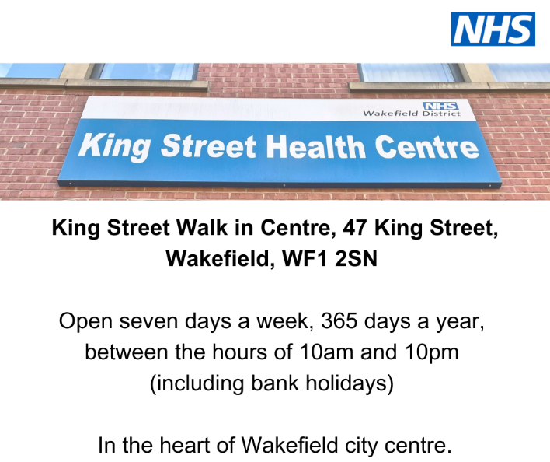 | The King Street Walk in Centre sign and NHS logo with the address, 47 King Street, Wakefield, WF1 2SN  Open seven days a week, 365 days a year, between the hours of 10am and 10pm (including bank holidays).  In the heart of Wakefield city centre.
Local GPs and nurses across Wakefield are still here to help even when practices close on an evening💙  Extra same-day and routine appointments are available locally 🕑  The fastest way to get advice, treatment and an appointment if needed at evenings and weekends 🩺  >>  🤒 Feel unwell & need help at evenings and weekends?  👩‍⚕️ If you think you might need to speak to a doctor, they’re still here.  📲 Just call your practice as usual and you’ll be diverted through to GP Care Wakefield. | 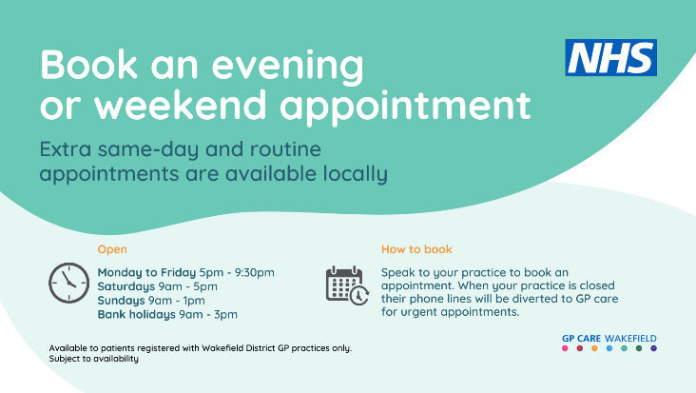 | Text saying ‘Book an evening or weekend appointment’ on turquoise background.  GP Care Wakefield opening times:  Monday to Friday: 5pm – 9:30pm  Saturday: 9am – 5pm  Sunday: 9am – 1pm  Bank Holidays: 9am – 3pm  Available to patients registered with a Wakefield District GP practice.  To book a routine appointment with GP Care Wakefield, please contact your practice reception team.  If you are unwell when your practice is closed and GP Care Wakefield is open, call your practice number to be automatically put through to GP Care Wakefield.
Local GPs and nurses across Wakefield District are still here to help when your practice is closed in the evening and at weekends. Ring your practice number, even if closed, to speak to a clinician and get a pre-bookable or urgent appointment.  @ConexusHealthUK | 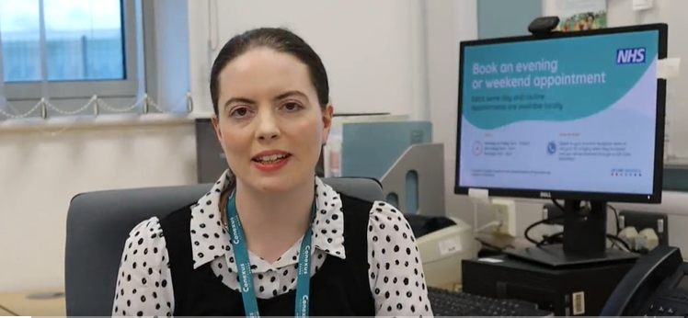 | Leah – GP Care Wakefield
West Yorkshire Healthier Together
If you’re worried about your child’s health this winter, you can find online healthcare advice - recommended by local healthcare professionals whenever you need it.  https://wyhealthiertogether.nhs.uk/ | 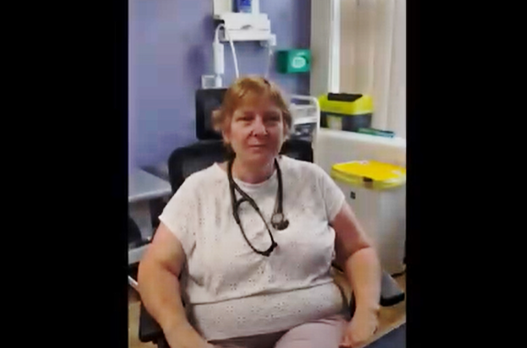 | Dr Carolyn Hall film
If you’re a parent or carer you can find local online information and advice to help keep your family safe and healthy this winter.  https://wyhealthiertogether.nhs.uk/ | 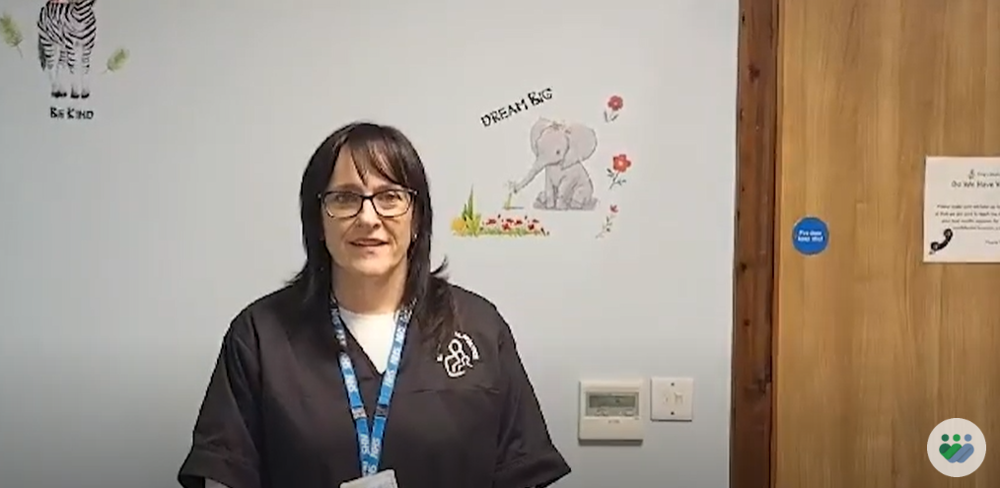 | Dr Jaz Walsh film
Worried your child needs an urgent appointment today but your GP practice won’t have any appointments left? Call them & check. They may be able to offer you an appointment tonight with GP Care Wakefield; the local evening weekend service for advice, appointments & reassurance.  www.wakefielddistricthcp.co.uk/news-blog/article/child-feeling-unwell-when-your-gp-surgery-is-closed/ | 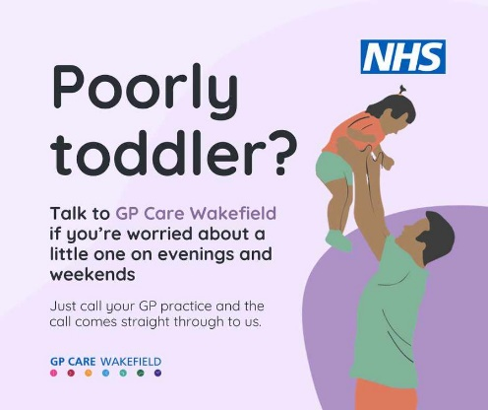

Proud to be part of West Yorkshire Health and Care Partnership

